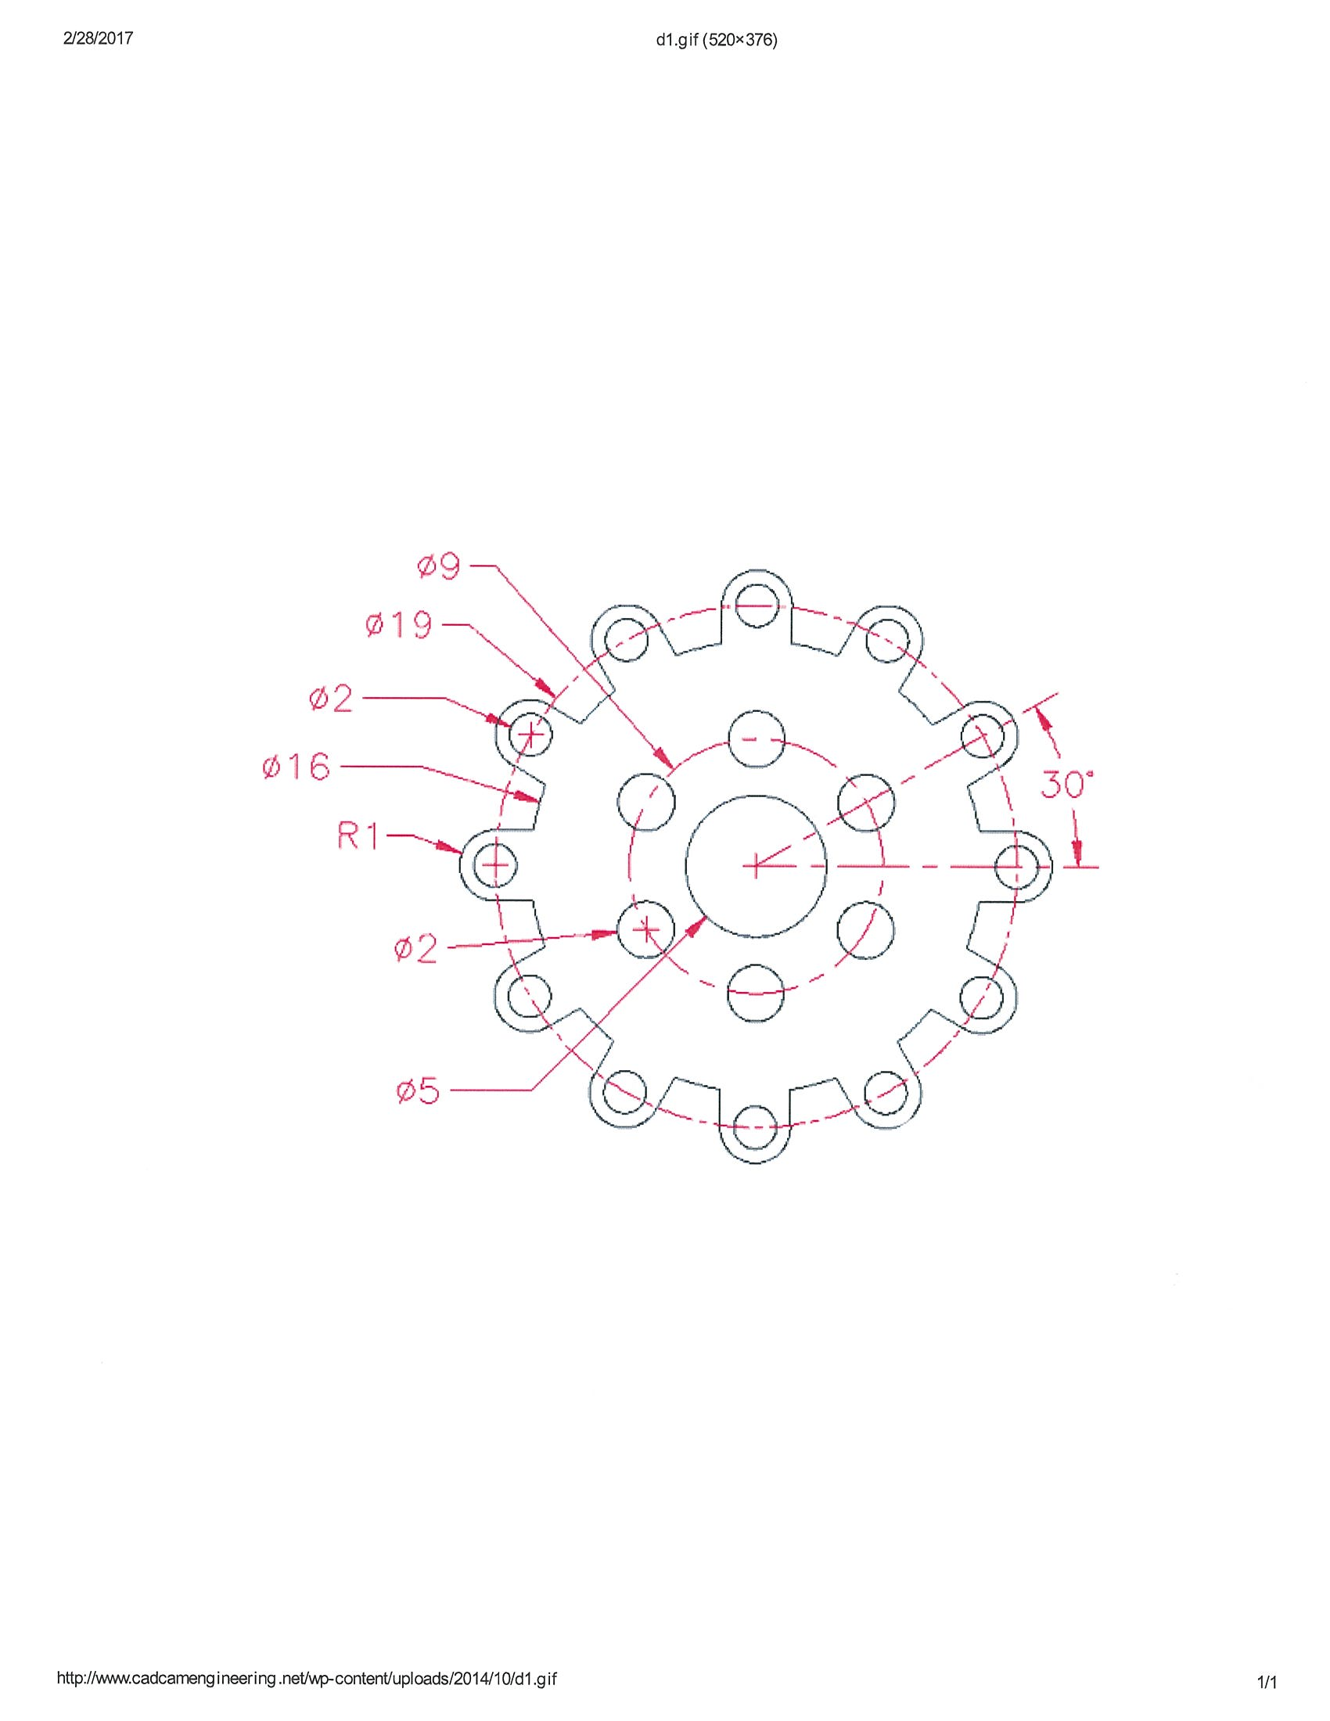

**Sprocket Coupler:**

* Offset Command
* Array Command
* Dimension Command
* DimCenter
* DimAngular
* DimRadius
* DimDiameter