Name:

12

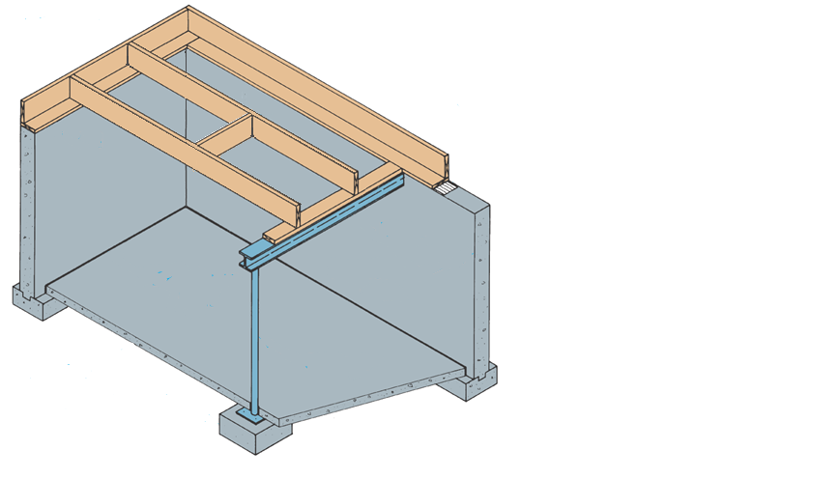

1

2

9

3

1:

2:

11

3:

10

4:

5:

6

7

8

6:

7:

8:

9:

10:

11:

4

5

12: