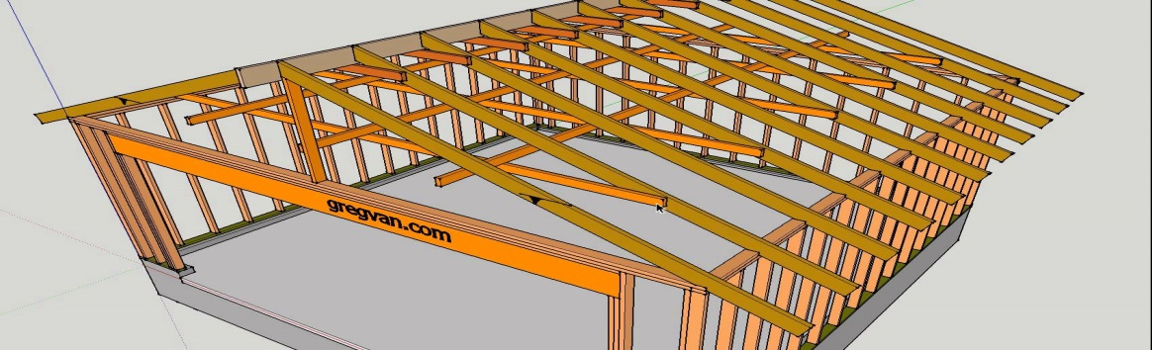
Name:____________________________________________________________
Rafter Quiz
True/False
- The span is the measurement from outside top plate to outside top plate. ___________
- The run is ¼ of the span. ______________
- A2 + B2 = C2. ____________________
- The cut out on the rafter that sits on the top plate is called a crow’s mouth. ___________
- The ridge cut is where the rafter meets the ridge board. _____________

List 3 measurements a speed square can measure
- _______________________
- _______________________
- _______________________
Calculate measurements
- Span is 20’ with a pitch of 5/12
Run=_____________
Rise=____________
Common Rafter Length=________________

- Run is 8’ with a pitch of 5/12
Run=_____________
Rise=____________
Common Rafter Length=________________

- Span is 10’ with a pitch of 5/12
Run=_____________
Rise=____________
Common Rafter Length=________________

- Span is 30’ with a pitch 5/12
Run=_____________
Rise=____________
Common Rafter Length=________________

- Run is 12’ with a pitch of 5/12
Run=_____________
Rise=____________
Common Rafter Length=________________

