Speaker Design Packet

Name-
Period-

Driver Specification Sheet – www.parts-express.com choose raw drivers that fit the following rules
8ohm impedance each – Low note of the tweeter should be at least double the high note of the woofer – Fill in any available specs
Driver Type: Tweeter
Brand:
Part #:
Price:
Product Specifications
Nominal Diameter:
Power Handling (RMS) :
Power Handling (max) :
Impedance:
Frequency Response:
Sensitivity:
Voice Coil Diameter:
Thiele-Small Parameters
Resonant Frequency (Fs) :
DC Resistance (Re) :
Voice Coil Inductance (Le) :
Mechanical Q (Qms) :
Electromagnetic Q (Qes) :
Total Q (Qts) :
Compliance Equivalent Volume (Vas) :
Mechanical Compliance of Suspension (Cms) :

BL Product (BL) :
Diaphragm Mass Inc. Airload (Mms) :
Maximum Linear Excursion (Xmax) :
Surface Area of Cone (Sd) :
Mounting Information
Overall Outside Diameter:
Baffle Cutout Diameter:
Depth:

Driver Type: Woofer
Brand:
Part #:
Price:
Product Specifications
Nominal Diameter: 5.25”-8”
Power Handling (RMS) :
Power Handling (max) :
Impedance:
Frequency Response:
Sensitivity:
Voice Coil Diameter:
Thiele-Small Parameters
Resonant Frequency (Fs) :
DC Resistance (Re) :
Voice Coil Inductance (Le) :
Mechanical Q (Qms) :
Electromagnetic Q (Qes) :
Total Q (Qts) :
Compliance Equivalent Volume (Vas) :
Mechanical Compliance of Suspension (Cms) :

BL Product (BL) :
Diaphragm Mass Inc. Airload (Mms) :
Maximum Linear Excursion (Xmax) :
Surface Area of Cone (Sd) :
Mounting Information
Overall Outside Diameter:
Baffle Cutout Diameter:
Depth:

www.diyaudioandvideo.com

-2-way Crossover Calculator
-Crossover frequency is the average of the low note of the tweeter and the high note of the woofer.

-Driver Attenuation Circuit Calculator
-Z=Impedance of tweeter
-A=The difference between the sensitivity of the woofer and tweeter.
-If (A)<1 you do not need an LPad

1st Order Butterworth
Hertz
Ohm Tweeter / Ohm Woofer
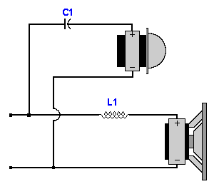 | Parts List  Capacitors  C1 = .  Inductors  L1 = .
LPad (Driver Attenuation Circuit)
Z = Ohms
A = db
Parts List

Resistors
R1 = Ohms
R2 = Ohms

Sealed or Ported Enclosure Calculator

-Use Woofer Specs
Free Air Resonance (Fs): | Hz
Driver Electrical "Q" (Qes):
Efficiency Bandwidth Product (EBP):
Recommendation:

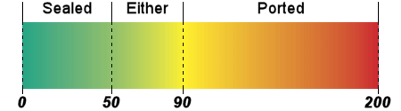

Speaker Box Designer Calculator

Vas = ft³
fs = Hz
Qts =
Qtc = (Sealed)
(Qtc must be greater than Qts, if using the provided woofer, change Qtc so that the vb becomes .25ft3)
D = in
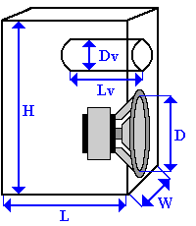 | Dimensions  Vb = ft³  f3 = Hz  fb = Hz  Dv = in (Ported)  Lv = in (Ported)
Vb: Speaker Box Internal Volume
f3: 3dB Cutoff Frequency
fb: Enclosure Resonant Frequency
Dv: Port Diameter
Lv: Port Length

Internal Box Dimensions
Use the lines below to calculate for X in inches. Round X to nearest 100th
4.096x^3=(vb)(1728)
W=X= D=1.6x= H=1.6(1.6x)=
Fill in the internal dimensions of your enclosure:
H=__________
D=_________
___
W=_________________

Determine which face will be the front. Look at the Overall Diameter of your woofer. If it is greater than X, the side becomes the front. Draw the circle representing the woofer on the correct face.

Panel Sizes and Plywood Layout

Front and Back: (W+1.5”) by (H+1.5”) _____x_______
Sides: (H+1.5”) by (D)__________x________________
Front
Top and Bottom: (W) by (D)________x_____________
Side

Bottom

Lay out the Panels to be cut out of the sheet of plywood. Arrange them in an efficient manner. You need six panels to make one speaker.
48”
48”

