Spinner
Objective
- Create a balanced spinner
  - Must be of your own design
  - Must encompass a theme
  - must use at least one bearing (maximum of 4)
  - Must have counter weights
  - Must fit in a 3” by 3” square. smaller size for smaller hands
- Prototype
  - spinner 1 should be a test spinner (prototype)
  - Spinner 2 will be your final working model
- Grade will be determined by
  - Design theme
  - balance
  - functionality
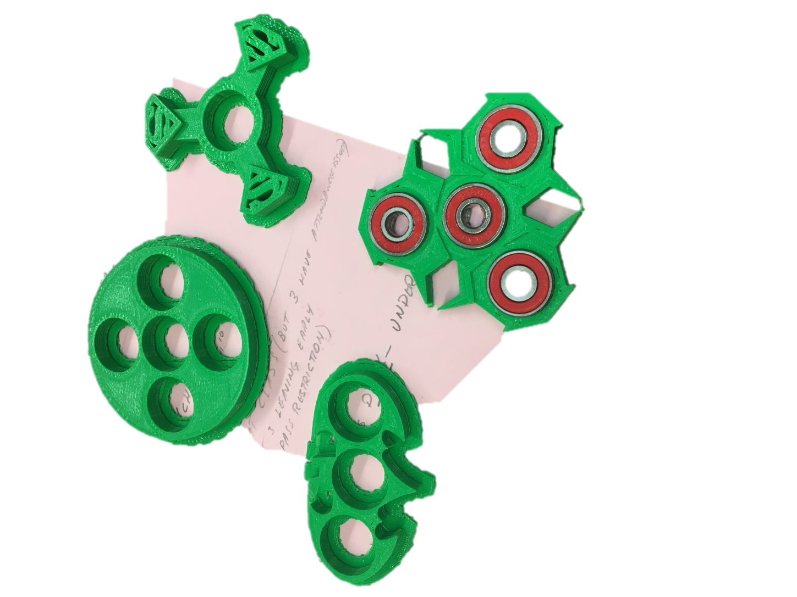
  - overall quality and appearance

